**101832 – Omondi Michelle – ICS 4B**

Lab 1 link:

**Lab 2**

Describe the output of a scanner (can be a sample sourced online or developed by yourself [5 Points]

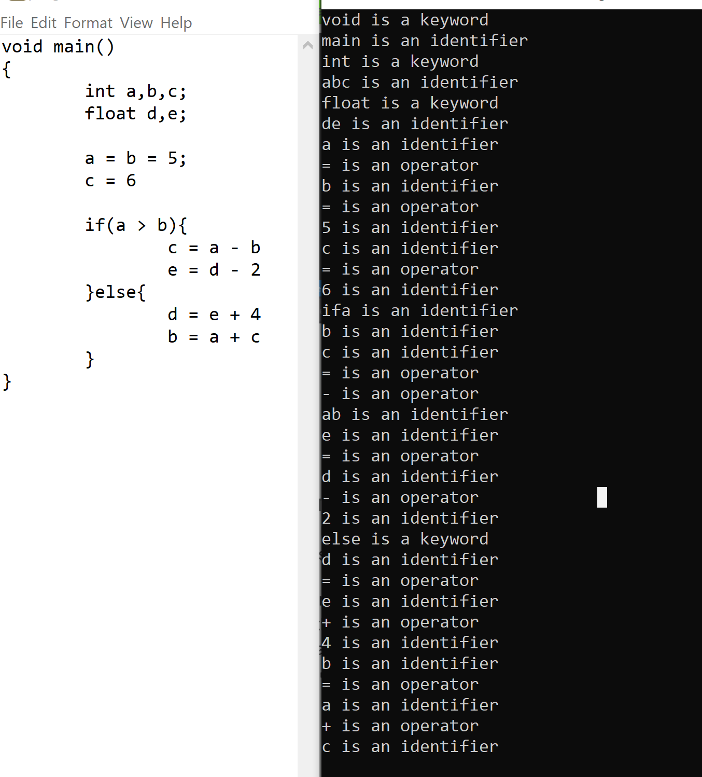

If the input to your program is in the correct format, the program should do lexical analysis on it and produce a sequence of tokens and lexemes according to the list of tokens specified in the program.

It strips out from the source program comments and white spaces in the form of blanks, tab and newline characters

The input string is partitioned into logical units of the language. This is implemented by reading left to right and recognizing one token at a time.

(Optional): Download and use Flex in anyway (Flex is an open source tool for developing a lexical analyzer [3 points]